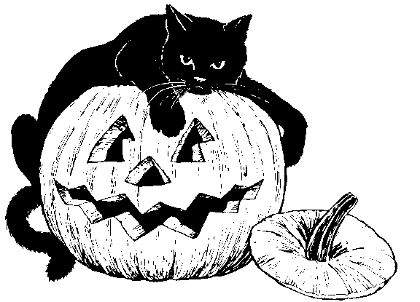 |  | 1  AM: Chex and Milk or Bananas  PM: Animal Crackers or Graham Crackers | 2  AM: Kix and Milk or Bananas  PM: Goldfish or Applesauce | 3  Am: Cornflakes and Milk or Bananas  PM: Animal Crackers or Applesauce
6  AM: Cornflakes and Milk or Bananas  PM: Goldfish or Animal Crackers | 7  AM: Kix and Milk or Bananas  PM: Goldfish or Applesauce | 8  AM: Chex and Milk or Bananas  PM: Animal Crackers or Goldfish | 9  AM: Cheerios and Milk or Bananas  PM: Goldfish or Applesauce | 10  AM: Cornflakes and Milk or Bananas  PM: Goldfish or Animal Crackers
13  Small Friends  Closed  Indigenous Peoples Day | 14  AM: Cornflakes and Milk or Cereal Bar  PM: Graham Crackers or Goldfish | 15  AM: Kix and Milk or Cereal Bar  PM: Animal Crackers or Goldfish | 16  AM: Chex and Milk or Cereal Bar  PM: Goldfish or Applesauce | 17  AM: Cornflakes and Milk or Cereal Bar  PM: Graham Crackers or Goldfish
20  AM: Chex and Milk or Bananas  PM: Animal Crackers or Cereal Bar | 21  AM: Cornflakes and Milk or Bananas  PM: Goldfish or Animal Crackers | 22  AM: Cheerios and Milk or Bananas  PM: Goldfish or Applesauce | 23  AM: Kix and Milk or Bananas  PM: Cereal Bar or Animal Crackers | 24  AM: Chex and Milk or Bananas  PM: Goldfish or Applesauce
27  AM: Kix and Milk or Cereal Bar  PM: Goldfish or Applesauce | 28  AM: Cheerios and Milk or Cereal Bar  PM: Animal Crackers or Goldfish | 29  AM: Cornflakes and Milk or Cereal Bar  PM: Applesauce or Goldfish | 30  AM: Chex and Milk or Cereal Bar  PM: Graham Crackers or Applesauce | 31  AM: Cornflakes and Milk or Cereal Bar  PM: Applesauce or Goldfish

